CSD201 PE INSTRUCTIONS
Students are ONLY allowed to use:
- Materials in his/her computer (including JDK, NetBeans...).
- For distance learning: Google Meet, Hangout (for Exam Monitoring Purpose).

Follow the steps below to complete PE:
- Create a folder named CSD_given (1). Down load given files to (1).
- Steps to do question 1 (do the same for questions 2 and 3): Open NetBeans, open the given project named Q1, then edit the file MyList.java according to questions in the exam paper (you should edit the file BSTree.java for Q2 and Graph.java for Q3).
- Submission: Create a folder with arbitrary name, e.g. CSD_PE (2). Create subfolders according to your coded projects, e.g. if you have edited and want to submit 3 projects Q1, Q2 and Q3 then create 3 subfolders Q1R, Q2R and Q3R inside (2), and copy
MyList.java from Q1\src to Q1R  BSTree.java from Q2\src to Q2R  Graph.java from Q3\src to Q3R | 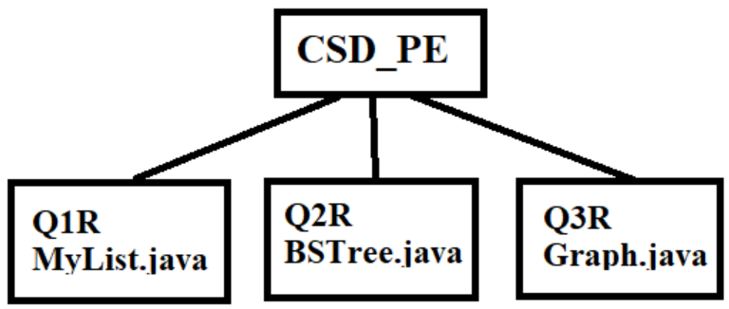
Do not submit un-edited files, e.g if you did not write code in given Graph.java, then you don’t need to create Q3R . When submiting, select the folder (2) and click Submit button (do not compress it). You can submit more times, but the newer will overwrite the older.
- Do not use accented Vietnamese when writing comments in programs.
- The version of Java being used must be 1.7 or 1.8
If at least one of the above requirements is not followed, the exam will get ZERO.

Important notice for marking: When marking data will be replaced. Output files f1.txt, f2.txt,... will be compared with the correct output files by the following way: Only file contents are compared. Leading and trailing spaces are not important. Space is important but number of spaces are not. New line is important but number of empty lines is not. Case of letters is important.

The contents may be included in PE:
Linked list (4 marks): Add (first, last, at position), edit, delete, find max, min, sort, reverse. The actions may be performed in the whole list or sub-list, e.g. sort or reverse elements from position k to position h (head’s position is 0).
Binary Search Tree (4 marks): Insert, edit, delete (by copying), traversals , rotate a node (to left, to right), calculate height, count number of nodes. The actions may be performed in the whole tree or sub-trees.
Graph (2 marks): Breadth, depth-first traversals, calculate degree of a vertex, check connectivity, Dijkstra’s shortest path algorithm, find Euler’s cycle or path using stack.

